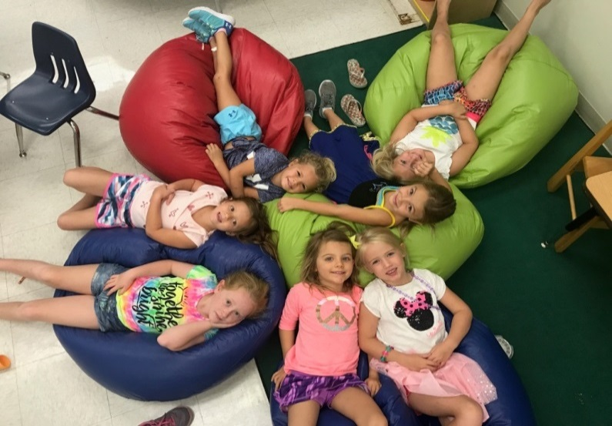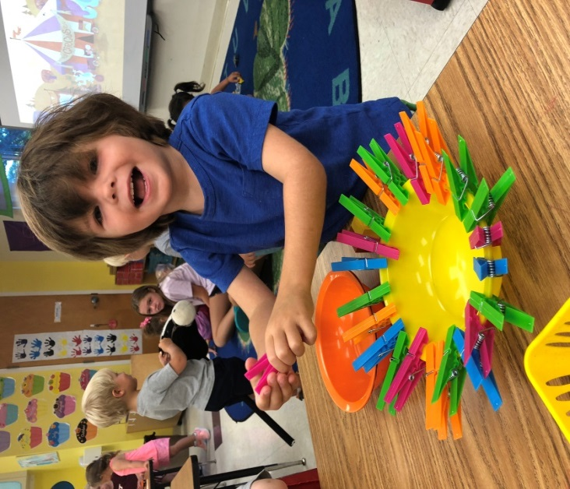

*\*\*\** ***Camp will be following school protocols based on CDC Guidelines***

**Our Mission**

**We exist to provide our students with a firm foundation for life and learning in a safe environment that meets the needs of each student.**

* **Challenging Academics**
* **Critical Thinking**
* **Character Building**
* **Creative Expression Christian Values**

In 1993, our School was founded as an outreach of the Church of the Good Shepherd with a simple goal: to enrich the lives of children of all faiths. It was a humble start, and yet by 1997, we had grown into a fully accredited Elementary School. A modern Art, Music and Science wing

was added in 2012. You cannot walk onto our campus without immediately feeling a sense of community. You will find Staff, Parents and Volunteers working together toward a common goal. Please schedule a tour and see for yourself!

We serve students in Early Learning (ages 2 and 3 years old),

PreKindergarten, and Kindergarten through Fifth Grade.

402 Seabrook Road, Tequesta, FL 33469

(561) 746-5507

admin@goodshepschool.com

http://goodshepschool.com

*ARTS & SCIENCES ACADEMY AT*

*GOOD SHEPHERD EPISCOPAL SCHOOL*

2021 SUMMER DAY CAMP

Fabulous Fun for

Ages 2 through 6



Learning to Love,

Loving to Learn

Published: 4/1/16

**Ages**  Ages 2 - 3 years old (potty trained)

Ages 4 - 6 years old

**Sessions**  June 7 – July 30

**Full Day** 9:00 am – 1:00 pm

**Extended Day** 9:00 am – 3:00 pm

**Pricing:**

**1 Week 4 Weeks 8 Weeks**

**Single (of your choice) (all)**

Full Day $175 $625 $1225

Extended Day $250 $925 $1825

**Registration and General Information**

**Registration:**

All camp sessions are filled on a “first come first served” basis.

To reserve your spot, please return the enclosed Registration Form with payment. Payments are non-refundable but may be applied to different sessions when space allows.

**General Information:**

Students are grouped by age and all groups are supervised by one of our certified teachers.

Please send your child with a reusable water bottle, small snack and lunch. Apply sunscreen before dropping off.

Please call 746-5507 with questions.

*\*\*\** ***Camp will be following school protocols based on CDC Guidelines***

**Session 1: June 7- June 11**

**World Travelers** – Come explore the world as we go back in time. We will go on a dinosaur expedition, explore a pyramid and perhaps meet royalty. Time travel with us as we go back in time.

**Session 2: June 14 – June 18**

**A Pirate’s Life** – Ahoy ye land lubbers! Campers can weigh anchor from land as they come aboard Captain Blackbeard’s pirate ship to help Captain Blackbeard and his mateys find buried treasure.

**Session 3: June 21 – June 25**

**Crafty Campers** – It’s time for crazy camp crafts. Have fun while painting on canvas, designing airplanes, making beads and jewelry and so much more!

**Session 4: June 28 – July 2**

**Budding Builders** –Become architects and designers by making models of bridges, building towers and constructing roller coasters. The possibilities are endless!

**Session 5: July 6 – July 9 (**Closed July 5th)

**Sensational Sounds** – Come and explore the world of sound as we make musical instruments, identify sound effects and play snapping and clapping games.

**Session 6: July 12 – July 16**

**Fantastic Tales & Super Heroine Stories** – Our Awesome Super Hero Campers will strengthen their super powers through group projects and peer interactions that encourage positive relationships.

**Session 7: July 19 – July 23**

**Messy Mixtures & Experiments** – Messy science experiences are the best kind. Our campers will be surprised to find out what goes into homemade play dough, “oobleck,” and 3D sand painting.

**Session 8: July 26 – July 30**

**Maker Space Magic!** Campers will complete a series of challenges which require creativity and imaginations to solve problems using different crafty recycled materials.