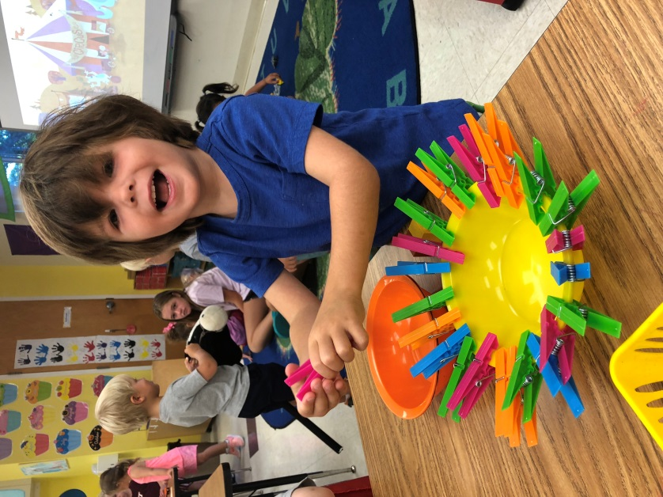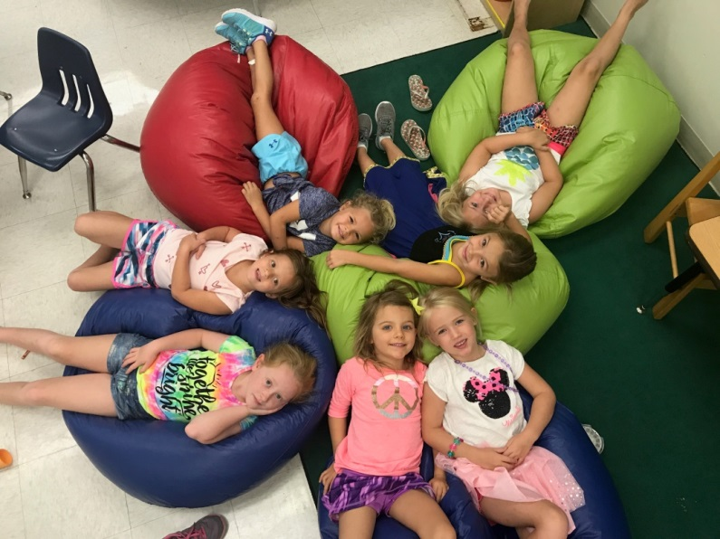

We serve students in Early Learning (ages 2 and 3 years old),

PreKindergarten, and Kindergarten through Fifth Grade.

**Challenging Academics ♦ Critical Thinking ♦ Character Building**

**Creative Expression ♦ Christian Values**

We provide our students with a firm foundation for life and learning in a safe environment that meets the needs of each student.

In 1993, our School was founded as an outreach of the Church of the Good Shepherd with a simple goal: to enrich the lives of children of all faiths. It was a humble start, and yet by 1997, we had grown into a fully accredited Elementary School. A modern Art, Music and Science wing was added in 2012. You cannot walk onto our campus without immediately feeling a sense of community. You will find Staff, Parents and Volunteers working together toward a common goal. Please schedule a tour and see for yourself!

402 Seabrook Road, Tequesta, FL 33469

(561) 746-5507

admin@goodshepschool.com

http://goodshepschool.com

*ARTS & SCIENCES ACADEMY AT*

*GOOD SHEPHERD SCHOOL*

2020 SUMMER DAY CAMP

Fabulous Fun for

Ages 2 through 6



Learning to Love,

Loving to Learn

Published: 4/1/16

**Ages**  Ages 2 - 3 years old (potty trained)

Ages 4 - 6 years old (entering Kindergarten)

**Sessions**  June 15 – August 7

**Half Day** 8:00 am – 12:00 pm

**Full Day** 8:00 am – 3:00 pm

**Pricing:**

**1 Week 4 Weeks 8 Weeks**

**Single (of your choice) (all)**

Half Day $175 $600 $1000

Full Day $225 $750 $1300

**Registration and General Information**

**Registration:**

All camp sessions are filled on a “first come first served” basis.

To reserve your spot, please return the enclosed Registration Form with payment. Payments are non-refundable but may be applied to different sessions when space allows.

**General Information:**

Students are grouped by age and all groups are supervised by one of our certified teachers.

Please send your child with a reusable water bottle, small snack and lunch. Apply sunscreen before dropping off.

***Wednesday is Water Day!*** Send your child in his/her

bathing suit along with a towel and change of clothes.

Please call 746-5507 for questions.

**Session 1: June 15- June 19**

Splish splash…we’re jumping into the ocean. Join us for a week of underwater fun while we discover what goes on under the sea.

**Session 2: June 22 – June 26**

Can you dig it? Let’s do a little digging and discover some interesting things about dinosaurs. What did they eat? How did they move? Where did they live? Join us to find out.

**Session 3: June 29 – July 2 (closed 7/3)**

Break out the stars and stripes and learn about what makes the USA such a special place. Discover the 50 states and learn a little bit about each one of them.

**Session 4: July 6 – July 10**

Get your teddy bears ready for a fun week of discovery. Learn all about hibernation and how bears survive in the wilderness. A special “Teddy Bear Picnic Day” will be held…so bring your special friend along for the fun.

**Session 5: July 13 – July 17**

Who’s at the zoo? How about you?

Join us for a week of adventure as we learn about all the wonderful animals you can find at our local zoos.

**Session 6: July 20 – July 24**

Creepy crawly, that’s for sure, but bugs are oh, so much more.

Learn about the special features of insects and how they help us

to survive.

**Session 7: July 27 – July 31**

Thunder and lightning and rain…oh my! Join us as we discover what makes weather happen and how we can learn to love even

those stormy days.

**Session 8: August 3 – August 7**

E-I-E-I-O…let’s go to the farm. So many wonderful creatures live on the farm, and we will be learning all about them. We will also learn how things grow, and will even plant a few seeds of our own.